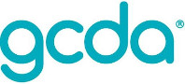
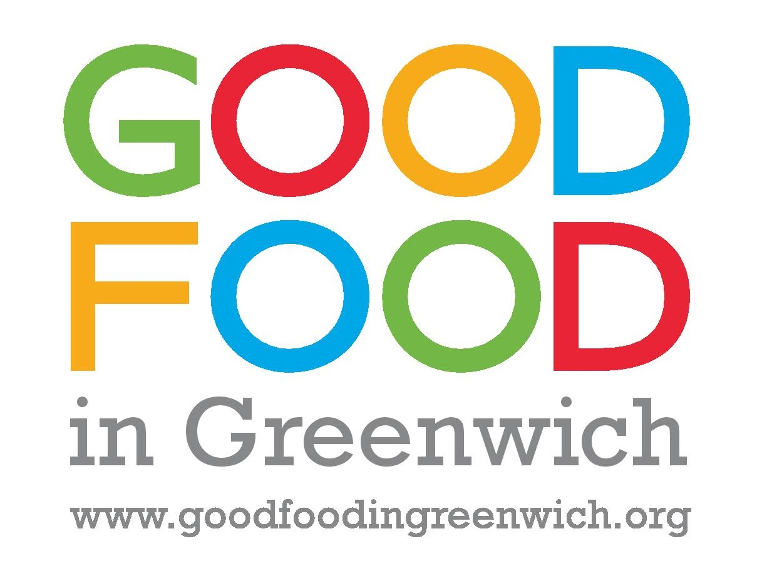
Good Food in Greenwich Comms Volunteer needed!

Role Description for Publicity and Communications volunteer

Working with: GCDA and Good Food in Greenwich Coordinator
Hours: Days and hours are flexible, but we’re looking for a commitment of 1 day a week.

Good Food in Greenwich is a network of organisations and individuals working towards a healthier, more sustainable Greenwich. It has been running for a year and half and covers many different areas of food including tackling food poverty, business support and waste. However, we cannot keep up with the work and are seeking a volunteer to support the network in all its communications and promotions.

We’re looking for someone enthusiastic and with a passion for healthy, sustainable food. We need someone who is willing to learn and who is experienced in using social media.

Key activities will include

- Supporting the network coordinator in promotions and communications and some administration
- Updating the Good FiG website with news and tips
- Promoting Good FiG through digital and social media
- Maintaining the database of Good FiG businesses and projects including sending out charters to Good FiG businesses
- Supporting with events administration
- Attending events to support on the day with photographs and social media

If possible we would also like someone who can write and distribute press releases to targeted media

This would be excellent experience for someone who wanted to gain more insight into the world of communications and get involved in an exciting and innovative partnership

For more information please contact Mel on 0208 2694880 or email mel@gcda.org.uk

